Schéma du circuit

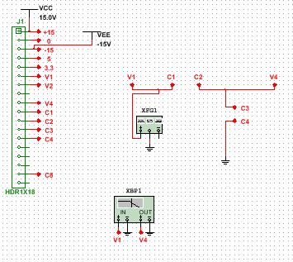

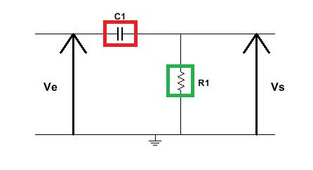

Caractéristiques

|  |  |  |
| --- | --- | --- |
| C  R | **R1=10k** | **R2=39k** |
| **C1=2.2nF** | **Fc=7.2KHz** | **Fc=1.8KHz** |
| **C2=10nF** | **Fc=1.6KHz** | **FC=400Hz** |

Routage

